Tutorial: How to make an Optical Tachometer with IR LED and Phototransistor
- Posted by GarageLab on August 22, 2014 at 2:30pm
- View Blog
Hello Everybody! In this tutorial we will be going over on how to build an optical tachometer with an Arduino UNO and Infrared sensors!
Basically our project goal will be to break the infrared-beam with an a DC motor arm revolution.
We are going to do a screen print up speed value as well.

We want to enable people to measure the motor speed of the DC motor so they could vary details and measure the effect the changes have on the motor speed and off course to introduce you guys the basics electronics concepts. I hope you enjoy!
Materials List:
1x Kit Arduino UNO Rev 3
1x IR LED
1x IR Phototransistor
1x Resistor 330R
1x Resistor 10KΩ
1x Protoboard
Jumpers wires
1.Tachometer
Figure 1 - Tachometer Example
An instrument for showing at any moment the speed of a revolving shaft, consisting of a delicate revolving conical pendulum which is driven by the shaft, and the action of which by change of speed moves a pointer which indicates the speed on a graduated dial.

2. Assembly
Please do the layout below!
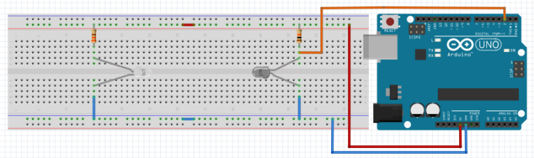
Figure 2 -How to assembly an Optical Tachometer
3. Sketch
#define sensor 2
long rpmconta=0;
void setup()
{
Serial.begin(9600);
}
void loop()
{
rpmconta = 0;
attachInterrupt(0, pegarpm, FALLING);
delay(1000);
detachInterrupt(0);
rpmconta = rpmconta * 60;
Serial.print(rpmconta);
Serial.println(" RPM");
}
void pegarpm()
{
rpmconta++;
}
References:
http://garagelab.com/profiles/blogs/tutorial-arduino-ir-sender-and-receiver

IR LED and Photodiode
The IR Object Detection sensor module is quiet easy to make. This sensor circuit below is a low cost - low range infrared object detection module that you can easily make at home using IR LED's. The Maximum input Voltage is 5 Volts.
We will use a photodiode and IR LED to make a simple circuit. IR led looks like a regular LED that you usually see in Television Remote controls.
For now I have added a regular LED to glow as in indicator when something is detected, you can replace it with a buzzer or something else the way you wish.
The Main concept is simple, the IR led keeps transmitting IR infrared rays up to some range (there is a potentiometer also in the design with the help of which you can alter the range). When some object comes in the (IR) infrared range, the IR waves hits the object and comes back at some angle, The Photo diode next to IR led detects that IR infrared rays which got reflected from the object and hence works as a proximity sensor. You can read more details about Proximity sensors for more.
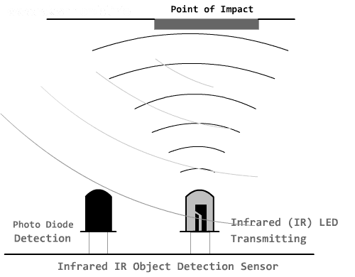
The components required to make this IR sensor can be easily found in any electronic stores and it is quiet inexpensive.

IR Sensor Circuit Module Requirements
1 - IR LED TSFF5210
1 - PR (photodiode) BPV10NF
1 - 1k resistance
1 - 220E resistance
1 - 6k8 resistance
1 - 10k potentiometer
1 - IC LM358

Infrared sensor Module Schematics
Following this schematic you can easily make it on a breadboard, I intentionally drew this schematic for this IR sensor this way so that it can easily printed on the copper board in no time if you have some etching solution.
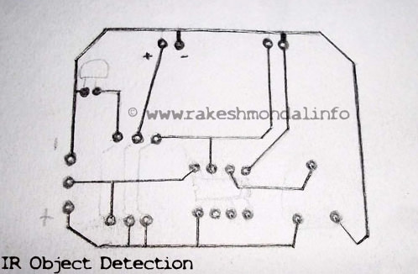
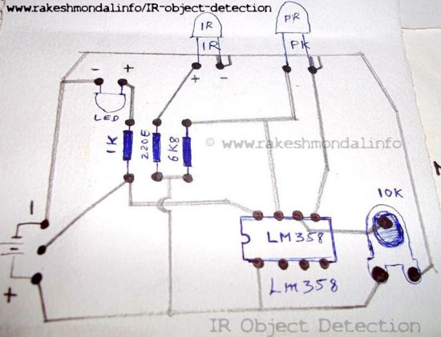
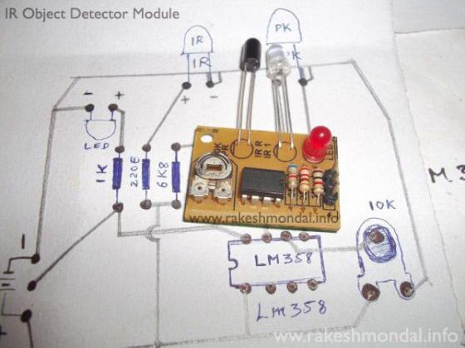
For now in this circuit an LED would glow as an example. Notice that there are three pins in the schematic in which two pins are used to provide power to the infrared sensor and the Middle pin is unused, and can be used for other operation. The Middle pin goes high (Logic 1) if the photodiode in this object detection module detects an object, and hence can be interfaced with other devices. You can use it the way you wish, it can be used to run some DC motors and make a simple robot. The middle pin of the IR Sensor Circuit can be interfaced with Microcontroller easily to do complex operations, or you can interface an LCD with microcontroller and have the status of the sensor displayed on the LCD very easily as in my next tutorial for interfacing multiple IR Sensors with Arduino and LCD.

How to Build a Proximity Detector Circuit
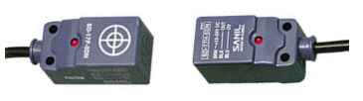
In this project, we will build a proximity detector circuit.
A proximity detector is gagdet that detects when an object is nearby.
There are 2 ways to build a proximity detector using IR LEDs and IR phototransistors.
One is mount the IR LED and the phototransistor so that they face each other. Then the infrared light is detected by the phototransistor. If an object comes between the IR LED and the phototransistor, the light is blocked, and the phototransistor turns off.
The other way is to build a proximity detector is to mount the IR LED and the IR photodiode next to each other facing the same direction. When an object comes near the IR LED, some infrared light will bounce off the object and be detected by the phototransistor.
In this project, we will build the former. We will place an IR LED and phototransistor so that they face each other. Thus, the phototransistor will normally be in conductive state. Only when an object comes in between the IR LED and the IR phototransistor will the phototransistor no longer conduct, because it doesn't have the infrared light beaming on it.
Components Needed
- 940nm IR LED
- 940nm Phototransistor
- 3 470Ω Resistor
- 4081 AND gate chip
- LED

The IR LED and the IR phototransistor has to be of the same wavelength. In this circuit, we will use a 940nm IR LED and phototransistor. But if you have another matching set, that can be used as well.
We will use the IR LED and IR phototransistor with a 4081 AND gate chip. This is a chip that can read input voltage levels and can determine whether the voltage is HIGH (above 1/2 of the supply voltage to the chip) or LOW (below 1/2 of the supply voltage). Thus, we use this NAND gate chip as a way of knowing voltage levels. Why this is important is because this voltage input will determine whether there is an object in between the IR LED and the IR phototransistor or not.
Normally, when the IR LED and the phototransistor are unimpeded, so that the phototransistor receives infrared light from the IR LED, current flows through the phototransistor. If you place a jumper wire after the resistor connected to the collector of the phototransistor, this can measure different voltage values when there is current flowing through the phototransistor (no object impeding the IR LED and IR phototransistor) and when there is no current flowing (object is impeding the IR LED from the IR phototransistor). It is through this jumper wire after the resistor on the collector terminal that allows us to know whether the transistor is conducting or not.
When the phototransistor is not conducting, the jumper wire will have a voltage that is close to the supply voltage on the collector terminal. This is when there is no current flowing through the phototransistor. This occurs when an object is impeding the IR LED and the IR phototransistor. This is how we know an object is there. Feeding this into the AND gate chip, we can know whether this voltage is HIGH (object detected) or LOW (no object detected).
When the phototransistor is conducting, the jumper wire's voltage will drop significantly to less than 1/2 of the supply voltage to the AND gate chip. This is when there is current flowing through the phototransistor. This occurs when no object is detected. Thus, the voltage will be LOW. If the phototransistor is not conducting, the jumper wiper's voltage will be greater than 1/2 the supply voltage to the AND gate. This occurs when an object is detected. Thus, the voltage will be HIGH.
So the AND gate chip can know whether there is an object detected or not by this voltage from the jumper wire after the resistor. An AND gate will produce a HIGH output when there is an object detected between the IR LED and the phototransistor. And it will produce a LOW output when there is no object detected. Thus, the output LED will turn on when an objected is detected and will be OFF when no object is detected.
The 4081 is an AND gate chip.
The pinout of the 4081 is shown below, so that you can see how to connect it in the circuit.
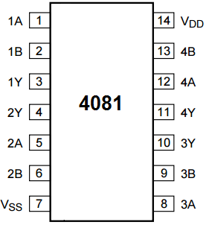
An AND gate will only turn its output HIGH when both inputs are HIGH. Since we tie both inputs together, it will produce a HIGH on the output when a HIGH input voltage is fed into it.

Proximity Detector Circuit
The schematic diagram of the proximity detector circuit we will build is shown below.
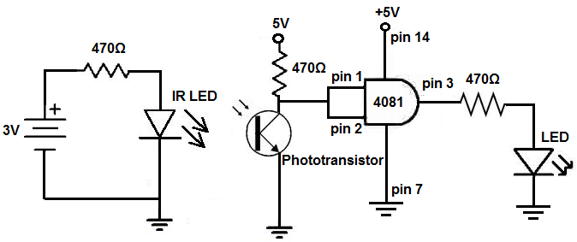
The above circuit shown on a breadboard is shown below.
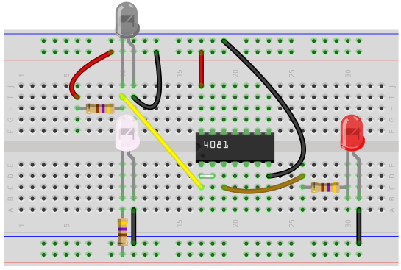
So the IR LED and the phototransistor should be placed so that the IR LED can beam the infrared on the phototransistor.
There should be a space in between them, though, so that if an object passes through in between them, it can be detected by the circuit.
And how it works is when the object passes between the IR LED and the phototransistor, it blocks the phototransistor from receiving the infrared. When this happens, the voltage at the collector terminal is HIGH. Being that we tied the 2 inputs of the AND gate together, this makes both inputs to the AND gate HIGH. When both inputs are HIGH to a 2-input AND gate, the output is HIGH. So, in this case when an object is impeding infrared light from being transmitted to the IR phototransistor, the output LED is ON.
If no object is impeding the infrared light from the phototransistor, then the phototransistor conducts current. When it conducts current, the voltage at the collector terminals drops to a LOW state. When it drops to a LOW state, the output of the AND gate is LOW. Therefore, the output LED is off.
Otras versiones de sensor de proximidad
https://www.youtube.com/watch?v=soa13KhVzsE
https://www.youtube.com/watch?v=j7ymvQY8zPE

